Given a list of lists of integers, nums, return all elements of nums in diagonal order as shown in the below images.

**Example 1:**

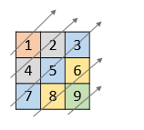

**Input:** nums = [[1,2,3],[4,5,6],[7,8,9]]

**Output:** [1,4,2,7,5,3,8,6,9]

**Example 2:**

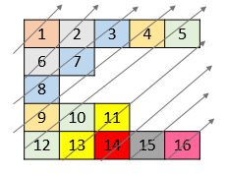

**Input:** nums = [[1,2,3,4,5],[6,7],[8],[9,10,11],[12,13,14,15,16]]

**Output:** [1,6,2,8,7,3,9,4,12,10,5,13,11,14,15,16]

**Example 3:**

**Input:** nums = [[1,2,3],[4],[5,6,7],[8],[9,10,11]]

**Output:** [1,4,2,5,3,8,6,9,7,10,11]

**Example 4:**

**Input:** nums = [[1,2,3,4,5,6]]

**Output:** [1,2,3,4,5,6]

**Constraints:**

* 1 <= nums.length <= 10^5
* 1 <= nums[i].length <= 10^5
* 1 <= nums[i][j] <= 10^9
* There at most 10^5 elements in nums.